EMERGENCY DETECTION SYSTEM FOR MOVING VEHICLES
A PROJECT REPORT
Submitted by
GIRISH BHARADWAJ.K BG105EC030
MADHAV R BHAT BG105EC054
SAMARTH .V BG105EC102
In partial fulfillment for the award of the degree of
BACHELOR OF TECHNOLOGY
IN
ELECTRONICS AND COMMUNICATION ENGINEERING

AMRITA SCHOOL OF ENGINEERING, BANGALORE
AMRITA VISHWA VIDYAPEETHAM
BANGALORE 560 035
MAY 2009
TABLE OF CONTENTS
CHAPTER | TITLE PAGE NO
 | ACKNOWLEDGEMENT i
 | ABSTRACT ii
LIST OF FIGURES viii

LIST OF TABLES x

LIST OF SNAPSHOTS xi

LIST OF ABBREVIATIONS xii
1. | INTRODUCTION 1
 | - Motivation 1
2. | LITERATURE SURVEY 2  2.1 General Description 2  2.2 Microcontroller MC9S12DP256 2  2.2.1 History 2  2.2.2 Operating temperature range 3  2.2.3 Operating frequency and voltage 3  2.2.4 Other on-chip peripheral features 3  2.3 Sensors 4  2.3.1 Pressure sensor 4  2.3.2 Temperature sensor 4  2.3.3 .Smoke sensor 4  2.4 Global Positioning System 5  2.5 Global System for Mobile 5  2.6 Software environment 6  2.6.1 Definition of IDE 6  2.6.2 Definition of target 7
3. | DESIGN 8
 | 3.1 Introduction 8
3.2 Project Requirements 8
3.2.1 Hardware Requirements 8
3.2.2 Software Requirements 9
3.3 Design of ADC Module 10
3.3.1 Functional description of sub modules 10
3.3.2 Successive approximation register 11 3.4 Serial Communication Interface 11
 | 3.5 Global Positioning System 13
3.5.1 Space segment 13
3.5.2 Control segment 14
3.5 3 User segment 15
3.5.4 Geo location determination 15
3.5.5 Measuring distance 15
3.5.6 NMEA Format 17
3.5.7 GPRMC 18
3.5.8 GPS Receiver operation 19
3.6 Global System for Mobile 22
3.6.1 GSM architecture 23
3.7 AT Commands 27
3.8 RS232 28
3.9 Design of sensor conditioning circuit 29
3.9.1 Temperature transducer 29
3.9.2 Smoke transducer 32
3.9.3 Pressure transducer 35
4. | SIMULATION 38  4.1 Software simulation 38  4.2 ADC flowchart 42  4.3 Flowchart for GPS code 43  4.4Flowchart for GSM 45
5. | TESTING 48
 | 5.1 Introduction 48
5.2 MCU testing 48
5.3 GPS testing 48
5.4 Testing the communication between PC and GSM modem 49
5.5 Condition Circuitry testing 49
 | 5.6 Software testing 49
6. | FUTURE ENHANCEMENT 51  REFERENCE LIST 55

LIST OF FIGURES
S.NO | FIGURE DETAILS | PAGE NO.
1. | Figure 1 Block diagram of EDS | ii
2. | Figure 3.1 ADC Architecture | 10
3. | Figure 3.2 SAR Module | 11
4. | Figure 3.3 Trilateration diagrams | 13
5. | Figure 3.4 Three segments of GPS | 14
6. | Figure 3.5 Calculation of distance | 16
7. | Figure 3.6 Mathematical view | 17
8. | Figure 3.7 Block diagram of GPS receiver | 19
9. | Figure 3.8 GSM system architecture | 24
10. | Figure 3.9 Various interfaces used in GSM | 25
11. | Figure 3.10 Pin out for LM35DZ | 29
12. | Figure 3.11 Pin diagram of µA741 | 29
13. | Figure 3.12 Temperature sensor conditioning circuit | 30
14. | Figure 3.13 Smoke sensor pin and connection diagram | 33
15. | Figure 3.14 Smoke sensor conditioning circuit | 33
16. | Figure 3.15 Pressure sensor conditioning circuit | 35
17. | Figure 3.16 Voltage divider circuit | 36
18. | Figure 4.1 New project wizard window | 38
19. | Figure 4.2 Microcontroller window | 39
20. | Figure 4.3 Language tool window | 39
21. | Figure 4.4 Processor expert window | 40
22. | Figure 4.5 Connection setting window | 40
23. | Figure 4.6 Bean selector window | 41
24. | Figure 4.7 ADC flowchart | 42
25. | Figure 4.8 GPS flowchart | 43
26. | Figure 4.9 GSM flowchart | 45

ACKNOWLEDGMENT
First and foremost ,we wholeheartedly bow down at the lotus feet of our beloved AMMA, chancellor , Amrita Vishwa Vidyapeetham for her blessings .
We are thankful to Dr. B.N Nagaraj, Principal, Amrita School of Engineering, for providing us a congenial environment to work in the college.
We wholeheartedly thank our project supervisor, Prof. S.K. Manocha, Department of Electronics and Communication Engineering, Amrita School Of Engineering, for continuously encouraging us to give our best efforts. His suggestion to improve the project is priceless and the support lent during the rough spots is fully appreciated.
We are also indebted to Prof . CGS Sarma , HOD, Department of Electronics and Communication Engineering , Amrita School Of Engineering, Bangalore, for his valuable guidance and support.
We express sincere gratitude to our project supervisors Mr. Ravikumar Manager Project And Consultancy Department and Mr. Surendra Kumar , Senior Engineer Project And Consultancy Department, at Bharat Electronics Limited, Bangalore for getting us this project spending their valuable time in guiding us during the process of the project.
Last but not the least, this project would not have been complete without the support, guidance and coordination of our parents and friends.

ABSTRACT
Defense is a crucial organization for every country. The problems involved in collecting and monitoring the data from remote locations and border areas in military operations are complex and challenging. The data has to be accurate, authentic and secured. It even has to be relayed at high speed. Thus, Bharat Electronics (BEL) decided to solve this issue by designing the Emergency Detection system (EDS).
The main objective of EDS is to act as an alerting machine that senses the vital signals and sends the signals to the concerned authorities through wireless technology.
What is fascinating about this project is the fact that it uses the concept of both embedded systems and wireless communication. Having undergone an elective course in Embedded systems and a compulsory course in Wireless communication, it was a chance for practical implementation of the subjects. The topics like GSM and GPS have a wide range of applications in almost all fields of day to day life not just limited to military purposes.
The major part of the project involved programming the Microcontroller unit, using Code Warrior IDE tool, in C language. It involved programming in two stages. The core application involves the microcontroller’s ADC was programming. Here the main settings were, setting the threshold voltages of each sensors. Next the microcontroller was programmed for serial communication among GPS, GSM, and the microcontroller.
The main implementations were
- Interfacing the GSM modem and GPS receiver with MCU.
- Designing the sensor conditioning circuit.

Block Schematic
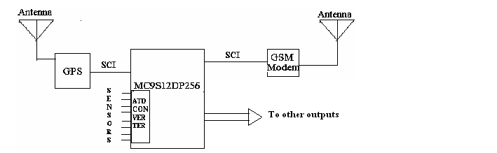
Figure 1 Block diagram of Emergency detection System

The first step was to get the various parameters of the automobile like temperature inside the vehicle, air pressure of the tyre and smoke levels inside the vehicle. So sensor was task divided among three team members by each one working on a single sensor and implementing it on a single board. Also the vital signals of the driver like blood pressure can be measured by using research grade blood pressure sensor. Secondly, a microcontroller unit is used to collect, process, and sample and store the data. To achieve wireless transmission of data to the concerned services GSM technology is used. Finally, a GPS modem is interfaced to the microcontroller unit to get the location, speed and time details of the moving vehicles to which the EDS is connected.

During the process of project work it was also learnt that the EDS has other potential applications in the following fields as.

- Industrial

To monitor the conditions in chemical and nuclear plants where it is humanly impossible to go and control the machines.

- Medical
It is especially useful in rural areas as a telemedicine unit. Different sensors like pulse sensors, cardiac monitors when installed can be used to communicate with doctors in house.

KEYWORDS
IDE, TDMA, binary search algorithm, Idle Line wake up, Receiver wake up, space segment, control segment, user segment, NMEA format, GPRMC,HLR, AUC, VLR, OMC.

LIST OF TABLES
S.NO. | TABLE DETAILS | PAGE NO.
1. | Table [3.1] Output readings of LM35 | 31
2. | Table [3.2] Output readings of smoke sensor circuitry | 34
3. | Table [3.3] Readings from strain gauge | 35
4. | Table [3.4] Readings from voltage divider circuit | 36
5. | Table [3.5] Readings from the pressure sensor conditioning circuit | 37

LIST OF SNAPSHOTS
S.NO | SNAPSHOT DETAILS | PAGE NO.
1. | Voltage divider circuit | 52
2. | Sensor condoning circuit | 52
3. | GSM modem | 53
4. | MCU | 53
5. | GPS receiver module | 54
6. | Complete setup | 54

SNAPSHOTS OF VARIOUS PROJECT MODULES

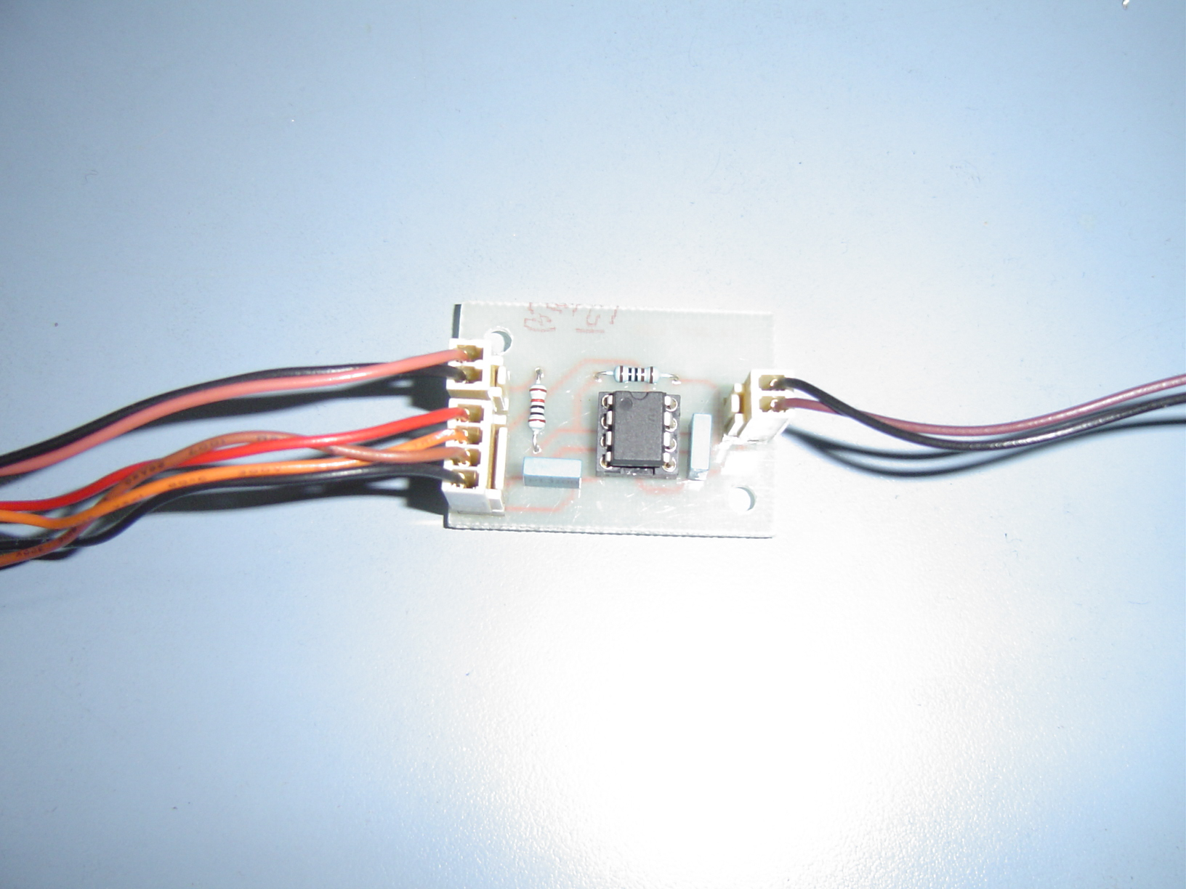
Snapshot 1. Voltage divider circuit

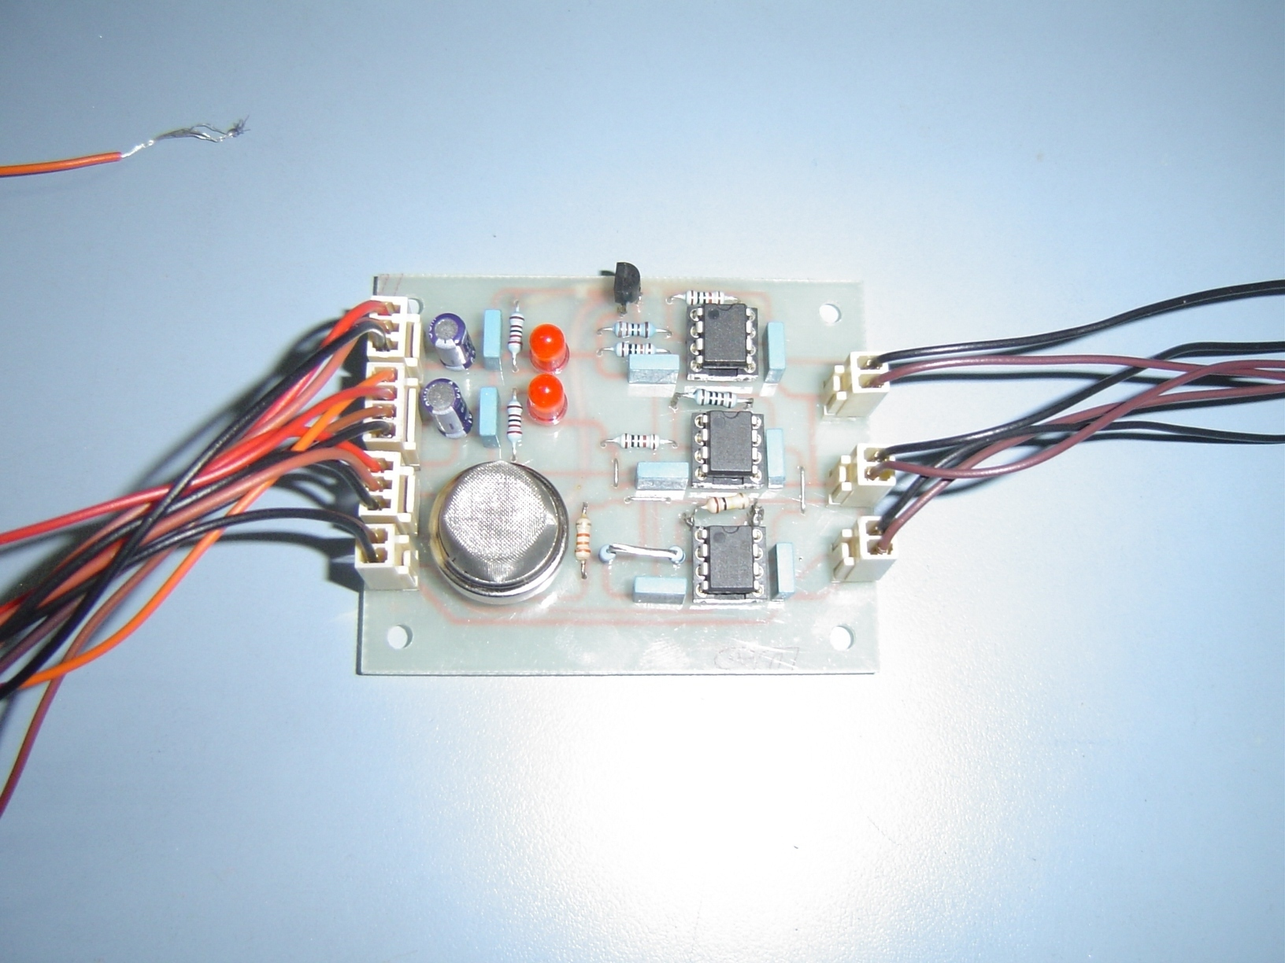
Snapshot 2 .Sensor conditioning circuit
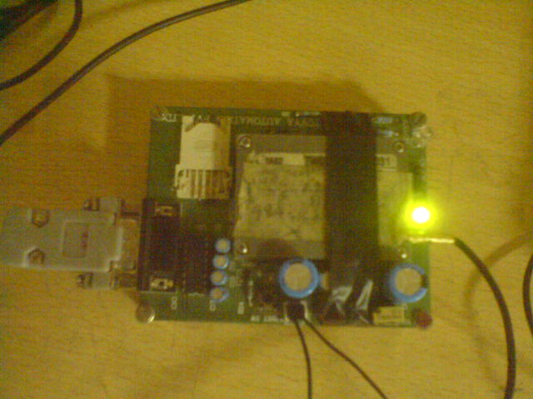
Snapshot 3. GSM Modem

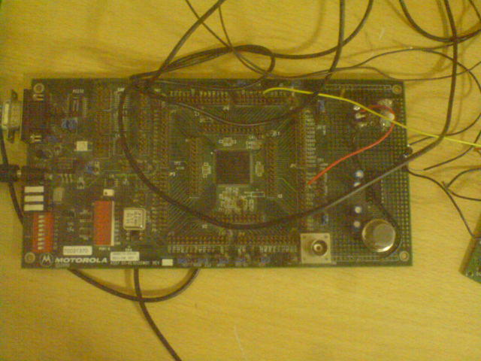
Snapshot 4. MCU
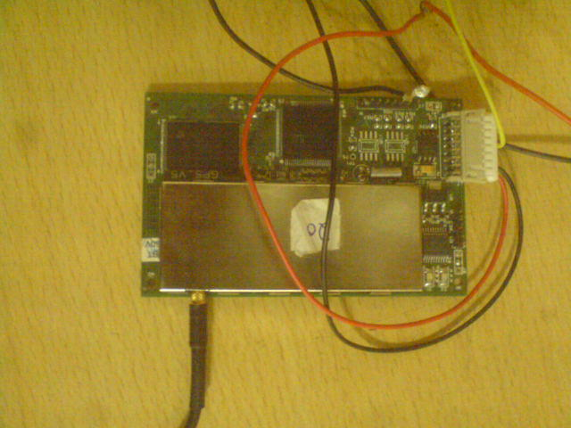
Snapshot 5.GPS Receiver Module

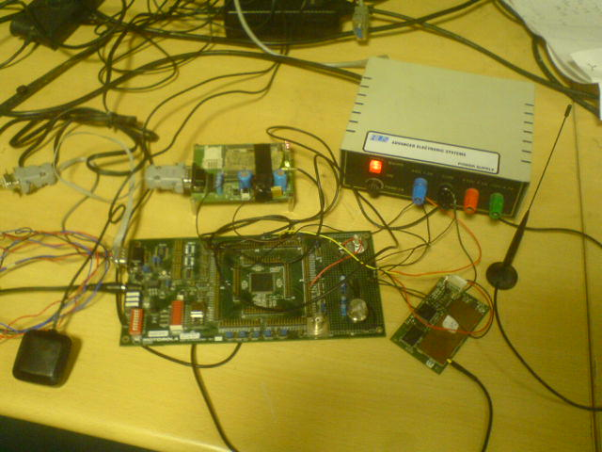
Snapshot 6. Complete Setup

LIST OF ABBREVIATIONS
ACRONYM ABBREVIATION

ADC - Analog to Digital Converter
ATD - Analog to digital module
AUC - Authentication Center
BPSK - Binary Phase Shift Keying
BSS - Base Station Subsystem
BSC - Base Station Controller
BTS - Base Transceiver Station
C/A - Course acquisition code
CDMA - Code Division Multiple Access
CEPT - Conference of European Post and Telecommunication
CMOS - Complementary Metal oxide Semiconductor
DAC - Digital to analog Converter
EDS - Emergency Detection System
EEPROM - Electrically Erasable Programmable Read Only Memory
GMSK - Gaussian minimum-shift keying
GPS - Global Positioning System
GPRMC - Global Positioning System Recommended Minimum Code
GSM - Global system for Mobile
HLR - Home Location Register
IDE - Integrated Development Environment
IMSI -International Mobile Subscriber Identity
MSB - Most significant Bit
MCU - Microcontroller Unit
NMEA - National Marine Electronics Association
NSS - Network and Switching Subsystem
OMC - Operation Maintenance Center
OSS - Operation Support Subsystem
PLL - Phase Locke0d Loop
RWU - Receiver wake up bit
SAR - Successive Approximation register
SCCP - Signaling Correction Control Part
Sci_rx_ind - unsynchronized transmit input signal
SCI -Serial Communication Interface
S/H - Sample and Hold
SMS - Short Messaging Service
SPS - Standard positioning service
TDMA - Time Division Multiple Access
VLR - Visitor Location Register
Vhv - High voltage
2G - Second Generation Technology

CHAPTER 1
INTRODUCTION
1.1 Motivation
The problems involved in monitoring the vital signals of the driver and the vehicle in remote locations are complex. The solution to this issue is to design an alerting machine that senses the vital signals of both vehicle and driver and sends these signals as messages to the concerned authorities. These messages are sent through GSM technology. The location of the vehicle is tracked by GPS.
To continuously and accurately monitor these vital signals, for extended periods of time, sensor networks were used. The sensors networks perform very effectively even in harsh environment conditions. Other advantages of these sensors are their added features like dedicated operation, fault tolerance, low cost and easy maintenance. The GPS technology helps to detect the location of the moving vehicle. It gives the latitude, longitude and speed of the moving vehicle. Finally the GSM modem transmits this message through wireless network to the desired persons mobile. EDS aims to provide a very simple and cost effective solution to demonstrate the feasibility and utility of this idea.

CHAPTER 2
LITERATURE SURVEY
2.1 General description
This project involves various hardware components such as a microcontroller unit, GPS receiver, GSM modem, temperature, and pressure and smoke sensors. The Code warrior IDE is used to program the microcontroller. The project uses the concepts of embedded systems, measurements and sensors and wireless communication network. This chapter highlights the details of each of the above topics.
2.2 Microcontroller MC9S12DP256
This is the heart of the whole project. This critical piece of hardware is responsible for majority of the tasks. It is interfaced with various sensors, the GPS modem and the GSM receiver.
2.2.1 History
During the early 1980’s Motorola emerged with a new technology called Microcontroller. It was developed from the typical microprocessor technology but with optimized computational speed and expanded memory size. It was based on Von Neumann architecture. Later in1990’s a highly integrated, general purpose family of microcontroller was introduced called the 6812 family. Their source code is compatible with the other 8 bit Motorola microcontrollers. The microcontroller used in this project belongs to the above family. The MC9S12DP256 MCU is a 16 bit device composed of several on chip peripherals. But this MCU was selected for this project because of its special features like.

2.2.2 OPERATING TEMPERATURE RANGE
It operates from -40 ᵒC to 125 ᵒC.This is a very big advantage because, the EDS have to work in the deserts as well as in the mountain regions for military applications. The MCU has to give accurate measures even in such extreme conditions.
2.2.3 OPERATING FREQUENCY AND VOLTAGE.
It operates from 0 to 5V. Hence it is a low power consumption device. Power is supplied to the MCU through V_{dd} and V_{ss}. Because fast signal transition takes place, short- duration current demands on the power supply, bypass capacitors with high frequency characteristics are placed as close as possible to MCU. It operates at 25 MHz frequency.
2.2.4 Other on- chip peripheral features includes:
It has got a 20 bit ALU that is mathematical operations can be performed on numbers up to a high range. It supports instruction pipelining, so the instruction are executed faster. The inclusion of PLL circuit allows low power consumption and performance to be adjusted to suit the operational requirements. 256K byte of Flash EEPROM ^{[1]}. It is this memory used during the development stage of the project because it takes only minutes to perform an edit/assemble/download cycle. The added advantage of using this microcontroller was that it could be easily programmed by the most familiar languages like C, C++. The programming voltage is generated internally by the on chip charge pumps. Also it supports ‘read while write’ for operations.
The main two modules of the MCU used in the project are
- 8 channel Analog to Digital converter.
- Asynchronous Serial Communication Interface.
2.3 Sensors
As of now three sensors are used in the project, but the number can be increased based on the applications. They are temperature sensor (LM35), smoke sensor (MQ-2) and pressure sensor.
2.3.1 Pressure sensor
The pressure sensor used in this project is the strain gauge, available in the Measurements and Circuits lab, Department of Electrical and Electronics Engineering, Amrita school of Engineering. It is manufactured by Unique Industries, Bangalore. The basic principle of working is change in strain of the material changes the resistance. Hence there is a variation voltage across the terminals of the material. Pressure readings vary from 0 to 10 Kg/cm².
2.3.2 Temperature sensor
The temperature transducer used is LM35. It is a precision centigrade temperature sensor which is manufactured by National Semiconductors. It generates a linear output voltage using a centigrade scale generating 10mV of output voltage for every degree centigrade change.
2.3.3 Smoke sensor
The smoke sensor used in this project is MQ-2. It is a semiconductor type smoke sensor manufactured by Hanwei Electronics Co. Ltd. The basic principle is the change in the sensor resistance when smoke is detected. The output voltage is measured across a load resistance of 33KΩ.

2.4 GPS (GLOBAL POSITIONING SYSTEM)
A network of satellites that continuously transmit coded information, which makes it possible to precisely identify locations on earth by measuring distance from satellite. The GPS was designed for military applications. Its primary purpose was to allow soldiers to keep track of their position and to assist in guiding weapons to their targets. The satellites were built by Rockwell International and were launched by the U.S. Air Force. Most GPS receivers understand the NMEA format 0183.
2.5 GSM (Global System for Mobile)
GSM is the most popular standard for mobile phones in the world. Its ubiquity makes international roaming very common between mobile phone operators, enabling subscribers to use their phones in many parts of the world. GSM differs from predecessors in that both signaling and speech channels are digital call quality, and thus is considered a second generation mobile phone system.
The ubiquity of the GSM standard has been advantageous to both consumers (who benefit from the ability to roam and switch carriers without switching phones) and also to network operators (who can choose equipment from many vendors implementing GSM). GSM also pioneered a low cost alternative to voice calls, the short message services (SMS, also called “text messaging”), which is now supported on other mobile standards as well.
GSM is a cellular network, which means that mobile phones connect to it by searching for cells in the immediate vicinity. GSM is a digital system employing TDMA technique.

2.6 Software Environment
The software development environment that is used in this application note is Metrowerks CodeWarrior IDE for HC12 target version 2.0
2.6.1 Definition of IDE
IDE’s normally consist of a source code editor, a compiler and/or interpreter, build automation tools, and (usually) a debugger. A single environment is provided for software development. They have the following features.
- Consistent operation.
- Move among all the tools freely.
3) Consistent look and feel, across environments and architectures.
4) Graphical and Command Line Build System.

In the CodeWarrior toolset, the Editor, Compiler, Linker, Debugger, and other software modules operate within an Integrated Development Environment, or IDE. The IDE oversees the control and execution of the tools. It provides an interface to the tools that is consistent and predictable. The Debugger enables to view source code, either as is or in assembly. Using the Debugger, breakpoints can be set, watch specific variables change can be watched, and move line-by-line through the program. Operation of the CodeWarrior runs on many different operating systems including Windows, Mac OS, Solaris, and Linux, with others to be added in the near future. The interface looks and operates the same on all environments. There are, of course, minor differences in screen appearance among host operating systems, but the functional capabilities are effectively the same. One of the greatest benefits of Code Warrior’s multi-platform approach is that your project files are completely transferable from one host operating system to another. For example, a project on the Star Core architecture is being done using the Windows hosted tools; the project files can be transferred to a Solaris system for final testing without needing to convert your project in any way. There is no need to run separate programs to run.

2.6.2 DEFINITION OF TARGET
A platform target is the chip or operating system selected for development.
Processor examples are HC(S) 08, Cold Fire, and Star Core. A build target is analogous to a makefile.
CodeWarrior IDE contains the following tools.
1) Project Manager: Handles top-level file items by major group, such as files and
targets , tracks state information (such as file modification dates), determines build order and inclusion of specific files in each build, coordinates with plug-ins to provide services like version-control.
2) Text Editor: Enables the creation and manipulation of source code and other textual files.
3) Search Engine: Finds a specific text string replaces found text with substitute text, allows use of regular expressions, and provides file-comparison and differencing functionality.
4) Source Browser: Maintains a symbolic database for the program, examples of symbols include names and values of variables and functions, links every symbol to other locations in the code related to that symbol, and processes both object-oriented and procedural languages.
5) Build System: Uses the compiler to generate relocatable object code from source code and uses the linker to generate a final executable image from object code. The CodeWarrior IDE uses projects and builds targets to organize the files and settings for creating a program. A project is a file that contains one or more build targets.

CHAPTER 3
DESIGN
3.1 Introduction
The project involves the designing of the following modules
• The ADC module designing.
• GSM modem designing.
• GPS module designing.
• Sensor conditioning circuitry design.
3.2 Project Requirements
Formally the requirements can be started under two heads, the software and hardware requirements respectively.
3.2.1 Hardware Requirements: The hardware requirements are stated for each of the modules separately as below.
• Micro-controller : MC9S12DP256B
• Sensors :
1) Temperature sensor LM35
Input temperature range: 0 °C to +100 °C
Supply voltage range: +35V to −0.2V
Output voltage range: 0 to 1V

2) Pressure sensor specifications:
Input pressure range: 0 to 1v
Output range: 0 to 15v
3) Smoke Sensor specifications:
Using temperature: -20 ˚C to 70 ˚C
Input voltage: 5V
Sensing resistance: 3kΩ to 33kΩ

• GSM ( Global System for Mobile)
Operating frequency Band: 900MHz
• GPS (Global Positioning System)
Operating frequency: 1575MHz (L1 Civilian Code)
• Power-source : DC Power Supply
• Serial Interface: RS-232 Port (interface to PC), USB link interface.
• PC
The PC must be running Windows XP and must have at least one serial (COM) port installed.
3.2.2 Software Requirements: Software requirements apply to both the PC as well as the micro-controller.
• MCU software
▪ Development Environment : Metrowerks CodeWarrior
3.3 DESIGN OF ADC MODULE.

Figure 3.1 ADC architecture
The A/D converter is designed as a peripheral bus environment for the MC9S12DP256 family. The A/D architecture is successive approximation architecture [1]. The core is 10 bit analog to digital converter implemented in a 0.25 micron CMOS process [1]capable of accepting inputs up to 5 volts while simultaneously operating at 5 volts. The resolution is 4.8mV. Speed is 128MHz.
3.3.1 Functional description of sub modules [2]
• Sample and Hold sub module.[2]
It accepts analog signals from the external world and stores them as the charge in the capacitor on a storage node. This sub module accepts as input a begin sample signal, a channel select code, 8 analog signals and power down signal. The output of this module is discritised analog sample and gives the end_sample after the conversion.
• Analog multiplexer[2]
This module selects one of the 8 incoming input channels and connects it to the sampling circuit.

3.3.2 Successive approximation register / (A/D) state machine

Figure 3.2 SAR module
The SAR [2] controls the conversion process in the A/D converter. The machine needs to know what is the value of the voltage stored in the capacitor at the storage node. Then it performs the binary search algorithm to find the nearest approximation to sampled signal given by the S/H[2] module. This module accepts the begin_convert, reset signal and two reference potentials. For power this module uses VDD, VSS, and Vhv (The in module generated high voltage). It can be also triggered by the external environments rather than relying only on the software to signal the ATD module. The results of this process in the result register. They are placed in the consecutive registers between the conversion sequences.
3.4 SCI (Serial Communication Interface)
The SCI [2] includes these distinctive features
SCI works in Full-duplex operation. It works in standard mark/space non-return-to-zero format. And the baud section rate is 13-bit.It has programmable 8-bit or 9-bit data format. The transmitter and receiver are enabled separately.
• Two receiver wakeup methods:
1) Idle line[2] wakeup method
WAKE bit is set 0. In this wakeup method, an idle condition is set on the sci_rx_ind signal clears the RWU bit and wakes up the SCI.
2) Address mark[2] wakeup
WAKE bit is set as 1. In this wakeup method, logic 1 in the MSB position of a frame clears the RWU bit and wakes up the SCI. The logic 1 in the MSB position marks a frame as an address frame that contains addressing information.
The RWU bit remains set and the receiver remains on standby until another address frame appears on the sci_rx_ind[2] signal. Other features are the receiver framing error detection and hardware parity checking.
Modes of operation
The SCI functions the same in normal, special, and emulation modes. It has three power modes namely,
1) Run Mode [2]
This is the basic mode of operation.
2) Wait Mode [2]
SCI operation in wait mode is a configurable low power mode. Depending on the state of internal bits, the SCI can operate normally when the CPU is in wait mode or the SCI clock generation can be turned off and the SCI module enters a power conservation state during wait mode. In the later case, any transmission or reception in progress stops at wait mode entry.
3) Stop Mode [2]
The SCI is inactive in stop mode for reduced power consumption. The STOP instruction does not affect SCI register states.

3.5 GPS- Global positioning System.
GPS is a satellite-based radio navigation system that allows anyone anywhere on the planet to determine their 3D position with good accuracy and precision. Applications of GPS include location, navigation, tracking and timing.
3.5.1 Space Segment
This consists of the satellite constellation that is orbiting the earth and the Delta rockets used to launch the satellites. In the GPS constellation there are 24 satellites that orbit the earth every 12 hours at an altitude of 20,200km. The satellites are organized into 6 equally spaced orbital planes (60 degrees apart), with 4 satellites per plane. Each satellite is inclined at 55 degrees to the equatorial plane to ensure coverage of the polar regions. This combination is designed to provide a user anywhere on the earth’s surface with 5-8 visible satellites. The satellites also have a variety of antennas to generate, send and receive signals. GPS receivers calculate the position of objects in two dimensional or three dimensional space using a mathematical process called trilateration. GPS uses 3D trilateration.

Figure 3.3 Diagrams showing trilateration.
3.5.2 Control Segment
The control segment of the GPS navigation systems consists of a Master Control Station which is supported by monitor stations and ground antennas. The monitor stations check the exact altitude, position, speed and overall health of the GPS satellite. A monitor station can track up to 11 satellites simultaneously and each satellite is checked twice a day by each monitor Station. The information collected by the monitoring stations is relayed to the Master Control Station to assess the behavior of each satellites orbit and clock. If any errors are noted then the Master Control Station directs the relevant ground antenna to relay the required corrective information to the relevant satellite

Figure 3.4 Three segments of GPS

3.5.3 User Segment
The User Segment refers to the civilian and military personnel who use the signals generated by the GPS satellites.

3.5.4 Geo-Location Determination
Geo-location using satellite navigation systems are based on the ability to measure the time taken for a signal to travel from a satellite to the receiver. Radio signals travel at the speed of light, which is constant, so if the time of travel is known then the distance between the satellite and the receiver can be determined. Since the position of the satellites is always known, thanks to the work by the control segment of the system, an unknown point (the user’s receiver) can be calculated if the receiver is obtaining signals from at least four satellites.

3.5.5 Measuring Distance

Each GPS navigation satellite continuously broadcasts its position along with timing data on two frequencies (L1 and L2). The L1 band carries two codes, Coarse Acquisition (C/A) code and Precision (P) code. The C/A signal is also termed “code phase” or Standard Positioning Service (SPS) and is the main signal used in civilian activity. The C/A and P signals take ~6 milliseconds (6/100ths of a second) to travel from satellite to receiver. The signals require a direct line of sight so receivers will not work indoors or under vegetation canopies/trees. Both the C/A and P signals have a time reference digital code referred to as a pseudo random code. Receivers contain an almanac of the pseudo random codes generate by the satellites and the time they are generated. When a receiver intercepts the digital code from a satellite it can compare the digital signal to its almanac to determine when the signal was generated. The time of travel is simply the difference between the time the signal was intercepted and the time it was generated. The difference between the C/A and P code is in the resolution of the code and thus the accuracy of timing and distance determination. As well as transmitting in “code phase”, satellites also transmit general satellite information in “carrier phase”. Carrier phase signals are broadcast on both the L1 and L2-band and at a much higher frequency than the code phase. The higher frequency permits a more accurate measurement of the range between the satellite and receiver. The product of time difference and velocity gives the distance.

Figure 3.5 Calculation of distance

Mathematical view
▪ Prs1+T+Es=sqrt((x-xs)^2+(y-ys)^2+(z-zs)^2)
▪ Prs2+T+Es=sqrt((x-xs)^2+(y-ys)^2+(z-zs)^2)
▪ Prs3+T+Es=sqrt((x-xs)^2+(y-ys)^2+(z-zs)^2)
▪ T-time error, Es-modeling error, Prs-approximate dist. From receiver to satellite.

Figure 3.6 Mathematical view
3.5.6 NMEA Format
GPS receiver communication is defined within this specification. Most computer programs that provide real time position information understand and expect data to be in NMEA format. This data includes the complete PVT (position, velocity, time) solution computed by the GPS receiver. The idea of NMEA is to send a line of data called a sentence that is totally self contained and independent from other sentences. There are standard sentences for each device category and there is also the ability to define proprietary sentences for use by the individual company. The NMEA has developed a specification that defines the interface between various pieces of marine electronic equipment.
Each sentence begins with a '$' and ends with a carriage return/line feed sequence and can be no longer than 80 characters of visible text (plus the line terminators). The data is contained within this single line with data items separated by commas. The data itself is just ASCII text and may extend over multiple sentences in certain specialized instances but is normally fully contained in one variable length sentence. The data may vary in the amount of precision contained in the message. The hardware interface for GPS units is designed to meet the NMEA requirements. They are also compatible with most computer serial ports using RS232 protocols. The interface speed can be adjusted on some models but the NMEA standard is 4800 b/s (bit per second rate) with 8 bits of data, no parity, and one stop bit. At 4800 b/s you can only send 480 characters in one second. Since an NMEA sentence can be as long as 82 characters you can be limited to less than 6 different sentences. Most GPS receivers understand the standard which is called 0183 version 2. This standard dictates a transfer rate of 4800 b/s.
3.5.7 GPRMC
Though the receiver gives the GPS data in 4 sentence formats, this project uses the GPRMC format since it gives us information regarding the latitude, longitude, date and time which are required by us. An example of this is.
$GPRMC,123519,A,4807.038,N,01131.000,E,022.4,084.4,230394,003.1,W*6A
Where:
RMC Recommended Minimum
123519 Fix taken at 12:35:19 UTC
A Status A=active or V=Void.
4807.038,N Latitude 48 deg 07.038' N
01131.000,E Longitude 11 deg 31.000‘ E
230394 Date - 23rd of March 1994

3.5.8 GPS receiver operation
A patch antenna is used in the GPS receiver. A patch antenna consists mainly of a square conductor mounted over a ground plane. The dimensions of the square are roughly 1/2 wavelength. The insulating space between the two planes may be air. The operating frequency of the GPS satellites is 1575 MHz So half a wavelength is about 300000/1575/2 = 95 mm

Figure 3.7 Block Diagram of GPS receiver
The principle block diagram of a GPS receiver is shown on Figure 3.7. The radio signals collected by a receiving antenna are weak. A low-noise amplifier will prevent any further degradation of the signal-to-noise ratio, but it cannot reduce the thermal noise collected by the antenna nor unwanted navigation satellite transmissions on the same frequency. GPS satellite signals are wideband, ranging from 1MHz to 20MHz (GPS P-code)
GPS signals are direct-sequence spread-spectrum signals, using Code-Division Multiple Access (CDMA) techniques. A GPS receiver will first down converts the signals to a suitable IF and amplifies them before further processing. At this stage a wide IF filter, corresponding to the complete original signal bandwidth, can be used to improve the dynamic range of the receiver. The down converter may be made tunable if widely separated channels are to be received, like the C/A-transmissions.
The wideband IF signal is then multiplied by (mixed with) a locally-generated satellite signal replica. If the locally generated code is synchronized to the satellite transmission, the bandwidth of the desired mixing product will collapse down to almost zero, since two identical 0/180-degrees BPSK modulation processes exactly cancel each other. On the other hand, the bandwidth of all unwanted signals, like noise or interferences, will be further expanded by this operation to a double bandwidth. Since the bandwidth of the desired signal collapses, this operation is usually called signal spectrum dispreading. The desired signal can now be filtered-out with a narrow IF filter having a bandwidth ranging from 100Hz to 10kHz in a GPS receiver. After the narrow IF filter, the signal-to-noise ratio finally achieves usable values and typically reaches 20dB.
The filtered IF signal is then used for several purposes. First, it is used to acquire and maintain synchronization of the locally generated code. Dithering the locally-generated code back and forth by a fraction of the bit period generates an amplitude modulation on the filtered signal. The phase of this modulation contains the information required to keep the synchronization of the local code generator.
The filtered IF signal is also fed to a BPSK demodulator (usually a squaring PLL or a Costas PLL) to extract the 50bps navigation message data. The BPSK demodulator also provides a regenerated carrier that is used for Doppler-shift measurements. On the other hand, the code-timing information is obtained from the local code generator. All three signals, code timing, Doppler shift and 50bps navigation data are fed to the receiver CPU to compute the user position, velocity, accurate time etc.
For Earth-located, slowly-moving users, the Doppler shift on the satellite signals is mainly due to the satellite motion and amounts up to +/- 5kHz on the L1 frequency. In most cases some fine tuning will be required to compensate the Doppler shift in front of the narrow IF filter. Some fine-tuning capability is also required to compensate the local oscillator frequency drift. In GPS receiver all of the required frequencies are obtained from a single TCXO with a stability of a few parts per million. Since one part per million is 1.6 KHz at the L1 frequency, the frequency uncertainty of the receiver is comparable in magnitude to the expected Doppler shift. Like in all spread-spectrum systems, the initial code sync acquisition is a critical operation in a GPS receiver. Most receivers make an exhaustive search for C/A-code synchronization. Testing a possible code phase typically takes around 10 milliseconds each, so an exhaustive search may take more than 10 seconds. This figure needs to be multiplied by the number of frequencies tested, due to an unknown Doppler shift or unpredictable TCXO drift.
A "cold start" of a GPS receiver may therefore take up to a long period of time, since the receiver does not know which satellite to look for; or the Doppler shift. A "warm start" is much faster since the receiver should know the almanac satellite, the approximate user location and the approximate time. From this information one can get all visible satellites and compute the corresponding Doppler shifts, so that the code phase and the TCXO drift are the only unknowns left.
The period of the P-code is far too long to make an exhaustive sync search practical. All P-code receivers need to acquire the C/A-code first, decode the navigation data and synchronize their local P-code generator to the C/A-code transmission first. Since the P-code rate is only 10 times the C/A-code rate, there are very few possible P-code phases left to be tested to lock on the P-transmission.
GPS have been designed to supply timing codes, the user position being computed from the measured propagation time differences. Additionally, the user velocity can be computed from the already known position and the measured Doppler-shift differences on the signal carriers. Although the Doppler shift can also be measured on the code rates, this measurement is usually very noisy. On the other hand, no absolute delay difference can be measured on the carrier, since the carrier phase becomes ambiguous after 360 degrees. Finally, relating the carrier phase to the code phase may produce excellent results, but requires an accurate compensation of ionospheric effects.
3.6 GSM (Global System for Mobile)
GSM networks operate in four different frequency ranges. Most GSM networks operate in the 900MHz or 1800MHz bands. According to CEPT[3] (Conference of European Post and Telecommunication), in the 900MHz band the uplink frequency band is 890-915 MHz, and the downlink frequency band is 935-960 MHz. In the 1800MHz band uplink frequency band is 1805-1880 MHz and the downlink frequency band is 1710-1785 MHz .This 25 MHz bandwidth is subdivided into 124 carrier frequency channels, each spaced 200 kHz apart. Time division multiplexing is used to allow eight full-rate or sixteen half rate speech channels per radio frequency channel. There are eight time slots (giving eight burst periods) grouped into what is called a TDMA frame. Half rate channels use alternate frames in the same time slot. The channel data rate is 270.833 Kbit/s, and the frame duration is 4.165ms. The transmission power in the handset is limited to a maximum of 2 Watts in GSM850/900 and 1 Watt in GSM1800/1900.
There are five different cell sizes in a GSM network- macro, micro, pico, femto and umbrella cells. The coverage area of each cell varies according to the implementation environment. The coverage area of each cell varies according to the implementation environment. Macro cells can be regarded as cells where the base station antenna is installed on a mast or a building above average roof top level. Micro cells are cells whose antenna height is under average roof top level; they are typically used in urban areas. Pico cells are small cells whose coverage diameter is a few dozen meters; they are mainly used indoors. Femto cells are cells designed for use in residential or small business environments and connect to the service provider’s network via a broadband internet connection. Umbrella cells are used to cover shadowed regions of smaller cells and fill in gaps in coverage between those cells.
Cell horizontal radius varies depending on antenna height, antenna gain and propagation conditions from a couple of hundred meters to several tens of kilometers. The longest distance the GSM specification supports in practical use is 35 kilometers.
The modulation used in GSM is Gaussian minimum-shift keying (GMSK), a kind of continuous-phase frequency shift keying. In GMSK, the signal to be modulated onto the carrier is first smoothed with a Gaussian low-pass filter prior to being fed to a Frequency modulator, which greatly reduces the interference to neighboring channels (adjacent channel interference). The GSM modem that we used in our project is manufactured by Conexant.
3.6.1 GSM architecture
The GSM system architecture consists of three major interconnected subsystems that interact between themselves and with users through certain network interfaces. The subsystems are the Base Station Subsystem (BSS) [3], Network and Switching Subsystem (NSS) [3], and the Operation Support Subsystem (OSS) [3].
The BSS, also known as the radio subsystem, provides and manages radio transmission paths between the mobile stations and the Mobile Switching Center (MSC) [3]. The BSS also manages the radio interface between the mobile stations and all other subsystem of GSM. Each BSS consists of many Base Station Controllers (BSCs) which connect the MS to the NSS via the MSCs. The NSS manage the switching function of the system and allows the MSCs to communicate with other networks such as the PSTN and ISDN. The OSS supports the operation and maintenance of GSM and allows system engineers to monitor, diagnose, and troubleshoot all aspects of the GSM system.
Figure 3.8 shows the block diagram of GSM architecture. The mobile stations (MSs) communicate with the BSS over the radio interface. The BSS consists of many BSCs which connect to a single MSC, and each BSC typically controls up to several hundred Base Transceiver Stations (BTSs) [3]. Some of the BTSs may be co-located at the BSC, and others may be remotely distributed and physically connected to the BSC by microwave link or dedicated lease lines. Mobile handoffs (called handovers) between two BTSs under the control of the same BSC are handled by the BSC, and not the MSC. This greatly reduces the switching burden of the MSC.

Figure 3.8 GSM System Architecture
As shown in figure 3.9, the interface which connects to a BTS to a BSC is called the Abis interface. The Abis interface carries traffic and maintenance data, and is specified by GSM to be standardized for all manufacturers. In practice, however, the Abis for each GSM base station manufacturer has subtle difference, thereby forcing service providers to use the same manufacturer for the BTS and BSC equipment.

Figure 3.9 Various interfaces used in GSM
The BSCs are physically connected via dedicated/leased lines or microwave link to the MSC. The interface between BSC and MSC is called A interface, which is standardized within GSM. The A interface uses an SS7 protocol called the Signaling Correction Control Part(SCCP) [3] which supports communication between the MSC and BSS, as well as network messages between the individual subscribers and the MSC. The A interface allows a service provider to use base station and switching equipment made by different manufacture.
The NSS handles the switching of GSM calls between external networks and the BSCs in the radio subsystem and is also responsible for managing and providing external access to several customer databases. The MSC is the central unit in the NSS and controls the traffic among all the BSCs. In the NSS, there are three different databases called the Home Location Register (HLR) [3], Visitor Location Register (VLR) [3], and the Authentication Center(AUC) [3]. The HLR is a database which contains subscriber information and location information for each user who resides in the same city as the MSC. Each subscriber in a particular GSM market is assigned a unique International Mobile Subscriber Identity (IMSI) [3], and this number is used to identify each home user. The VLR is a database which temporarily stores the IMSI and customer information for each roaming subscriber who is visiting the coverage area of a particular MSC. The VLR is linked between several adjoining MSCs in a particular geographic region and contains subscription information of every visiting user in the area. Once a roaming mobile is logged in the VLR, the MSC sends the necessary information to the visiting subscriber’s HLR so that calls to the roaming mobile can be appropriately routed over the PSTN by the roaming user’s HLR. The Authentication Center is a strongly protected database which handles the authentication and encryption keys for every single subscriber in the HLR and VLR. The Authentication Center contains a register called the Equipment Identity Register (EIR) [3] which identifies stolen or fraudulently altered phones that transmit identity data that does not match with information contained in either the HLR or VLR.
The OSS supports one or several Operation Maintenance Centers (OMC) which is used to monitor and maintain the performance of each MS, BS, BSC, and MSC within a GSM system. The OSS has three main functions, which are 1) to maintain all telecommunication hardware and network operations with a particular market, 2) manage all charging and billing procedures, and 3) manage all mobile equipments in system.

3.7 AT COMMANDS
AT commands are instructions used to control a modem. Both GSM and dial-up modems support a common set of standard AT commands. AT is the abbreviation of AT tension. Every command line starts with “AT” or “at”. That’s why modem commands are called AT commands. Many of the commands that are used to control wired dial-up modems, such as ATD(Dial), ATA(Answer), ATH(Hook control) and ATO(Return to online data state), are also supported by GSM/GPRS modems and mobile phones. Besides this common AT command set , GSM/GPRS modems and mobile phones support an AT command set that is specific to the GSM technology, which includes SMS-related commands like AT+CMGS (send SMS message), AT+CMSS (Send SMS message from storage), AT+CMGL (List SMS message) and AT+CMGR (Read SMS messages) . Also AT+CSCA is used to seek permission from the network provider.
Note that the starting “AT” is the prefix that informs the modem about the start of a command line. It is not part of the AT command name. For example, D is the actual AT command name in ATD and +CMGS is the actual AT command name in AT+CMGS. However, some books and web sites use them interchangeably as the name of an AT command.
In addition, some AT commands require the support of mobile network operators. For example, SMS over GPRS can be enabled on some GPRS mobile phones and GPRS modems with the +CGSMS command (command name in text: Select Service for MO SMS Messages). But if the mobile network operator does not support the transmission of SMS over GPRS, cannot be used in the future.

3.8 RS232 SERIAL INTERFACE
To allow compatibility among data communication equipment made by various manufacturers, an interfacing standard called RS232 was set by Electronics Industries Association. In this project RS232 is used for the communication between GPS, GSM and PC. RS232 communication is asynchronous. That means first start bit is sent (0) followed by eight bit data, then stop bit (1) is sent.
This standard is used in PCs and numerous types of equipment. However, since the standard was set long before the advent of the TTL logic family, its input and output voltage levels are not TTL compatible. In RS 232, a 1 is represented by -3 to -25 V, while a 0 it is +3 to +25V, making -3 to +3 undefined. Also open circuit voltage should never exceed 25V. Short circuit current should not exceed 500mA. We are using RS 232 with D-type 9 pin male and female connectors.
3.9 DESIGN OF SENSOR CONDITIONING CIRCUITS
3.9.1 Temperature sensor
The temperature transducer that is used is LM35. It is an IC type of temperature sensor. It generates a linear output voltage using a centigrade scale – generating 10mV of output voltage for every degree centigrade change [4]. The principle of working of LM35 is, when temperature increases breaking of covalent bond happens which leads to change in output voltage. Typically LM35 stays accurate to within ±¾ °C over its temperature range so this is a good general purpose sensor and it's easy to use. LM35DZ operates in the temperature range of 0 to 100 ᵒC. Also supply voltage will be in the rage of 0 to 35V.
The output of LM35 will be in the range of 0 to 1000 mV. So a non-inverting amplifier was used to amplify the voltage. µA741 op-amp [5] is used .The output from the amplifier is given to ADC of microcontroller. Threshold level in ADC for temperature sensor is set into 2V. So whenever the input to ADC becomes greater than or equal to 2V, temperature high alert message will be sent.

Figure 3.10 Pin out for the LM35DZ (From top)

Figure 3.11 µA741 Pin diagram

Figure 3.12 circuit diagram of temperature sensor conditioning circuit
Calculations
From the circuit diagram,
R1= -Vs/ (50µA)
=-5/ (50µA)
=100KΩ.
Also,
Output of non-inverting amplifier, Vout = (1+ (R2/R1)*Vin.
Here Vin is the output from LM35. Also R1 = 3.3KΩ, R2 = 10KΩ
Therefore Vout= (1+ (10/3.3))*Vin
=4.03*Vin.

Procedure for measuring temperature sensor output
1. The circuit is connected as shown in the diagram.
2. Ordinary hair drier is used to increase the temperature surrounding LM35.
3. Thermometer is used to measure the temperature.
4. Power supply is switched on and the amplified output, Vout is measured at room temperature.
5. Now the temperature is increased and the output is measured at various temperatures starting from room temperature to 60 ᵒC.

Serial no.
Input (in ᵒC)
Output V1 (in Volts)
Output Vout (in Volts)

1. Room temperature (30)
0.3
1.27
2. 40 0.4 1.59
3. 50 0.5 2.0
4. 60 0.6 2.4
Table [3.1] Output readings of LM35

3.9.2 Smoke sensor (MQ-2)
The smoke sensor is composed of sensing element, sensor base and sensor cap [7]. The sensing element contains sensing material and heater to heat up sensing element (eg. 400℃). Depending on the target smoke, the sensing element will utilize different materials such as Tin dioxide (SnO2), Tungsten oxide (WO3), etc.
When a metal oxide crystal such as SnO2 is heated at a certain high temperature in air, oxygen is adsorbed on the crystal surface with a negative charge. Then donor electrons in the crystal surface are transferred to the adsorbed oxygen, resulting in leaving positive charges in a space charge layer. Thus, surface potential is formed to serve as a potential barrier against electron flow. Inside the sensor, electric current flows through the conjunction parts (grain boundary) of SnO2 micro crystals. At grain boundaries, adsorbed oxygen forms a potential barrier which prevents carriers from moving freely. The electrical resistance of the sensor is attributed to this potential barrier.
In the presence of a deoxidizing gas, the surface density of the negatively charged oxygen decreases, so the barrier height in the grain boundary is reduced. The reduced barrier height decreases sensor resistance.
The relationship between sensor resistance and the concentration of deoxidizing gas can be expressed by the following equation over a certain range of gas concentration:
Rs = A[C] -α
Where: Rs = electrical resistance of the sensor
A = constant
[C] = gas concentration
α = slope of Rs curve
Due to the logarithmic relationship between sensor resistance and gas concentration, semiconductor type sensors have an advantage of high sensitivity to gas even at low gas concentration.

Figure 3.13 Smoke sensor pin diagram and connection diagram

Figure 3.14 Smoke sensor conditioning circuit
Calculations
From the circuit diagram,
R1=33k
Also,
Output of non-inverting amplifier, Vout=(1+(R2/R1)*Vin.
Here Vin is the output from LM35. Also R1=10kΩ, R2 or R2= 0.5KΩ (Two 1k in parallel)
Therefore Vout = (1+(0.5k/10k))*Vin
=1.05*Vin
Procedure for measuring smoke sensor output
1. The circuit is connected as shown in the diagram.
2. Incense stick is used to create smoke and hold it near the sensor.
3. Power supply is switched on and Vout is measured.
Sl no. Output V1 (in Volts) Output Vout (in Volts)
1. 4.8 5.04
2. 4.85 5.09
3. 4.88 5.13
4. 4.92 5.17
Table [3.2] Output reading of Smoke sensor circuitry

3.9.3 DESIGN FOR PRESSURE SENSOR CONDITIONING CIRCUIT

Figure 3.15 Pressure sensor conditioning circuit
Vout=(1+R2/R1)*Vin
R1=7K, R2=100KWhere Vin is the output from the voltage divider. For the voltage divider, the input is from the strain gauge.
Input pressure in Kg/cm2 Output in milli volts
0.5 9.9
1 11.7
1.5 12.8
2.0 14.00
3 16.6
Table [3.3] Readings from the strain gauge

Figure 3.16 Voltage divider circuit

Input voltage in volts Output voltage in volts
1 0.1
5 0.5
10 1
Table [3.4] Readings from the voltage divider circuit

Input voltage in volts Output voltage in volts
0.1 1.52
0.5 7.64
1 15.26
Table [3.5] Readings from the pressure sensor conditioning circuit

CHAPTER 4
SIMULATION
4.1 Software Simulation
The step by step process for Code Warrior simulation is as follows.
- Code Warrior IDE tool is opened with the new project wizard option and a desired project name is given.
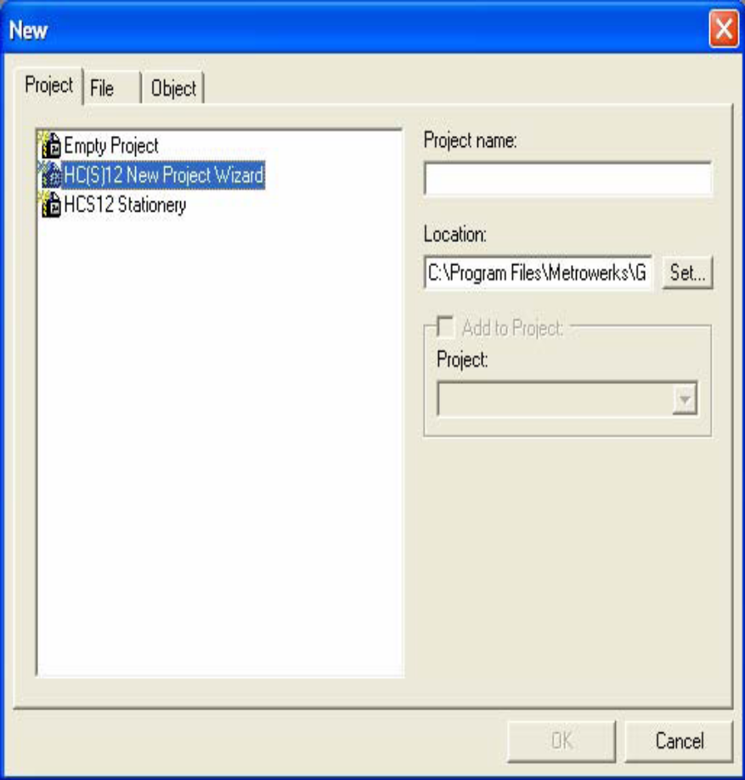
Figure 4.1 New project wizard window

- Required MCU for the project is selected.
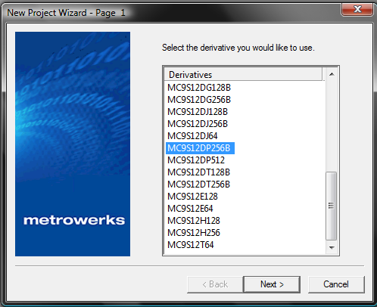
Figure 4.2 microcontroller window
- Language in which the code is to be written is selected.
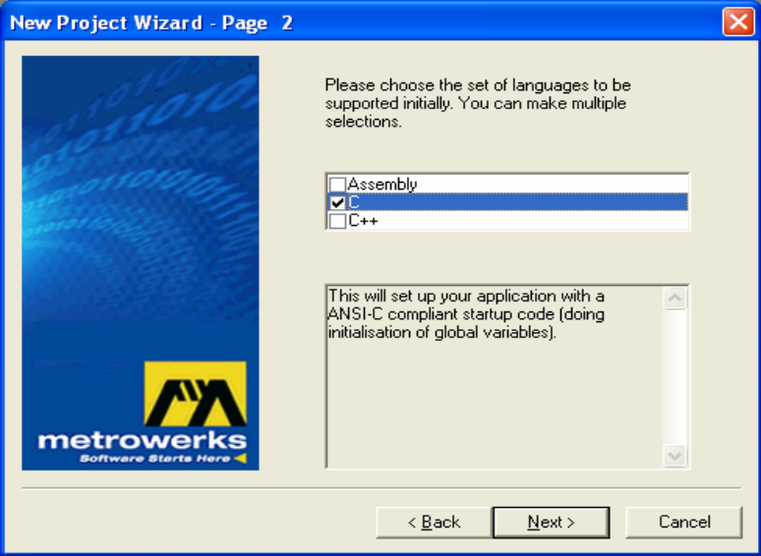
Figure 4.3 language tool window

4) Processor expert for generating the required device installation code is chosen.
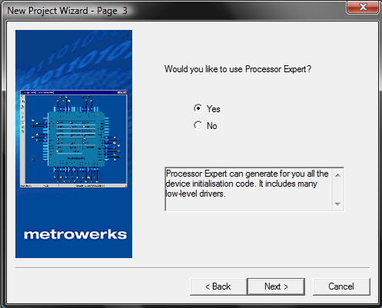
Figure 4.4 Processor expert window
5) Connections for chip simulation and hardware debugging is chosen.
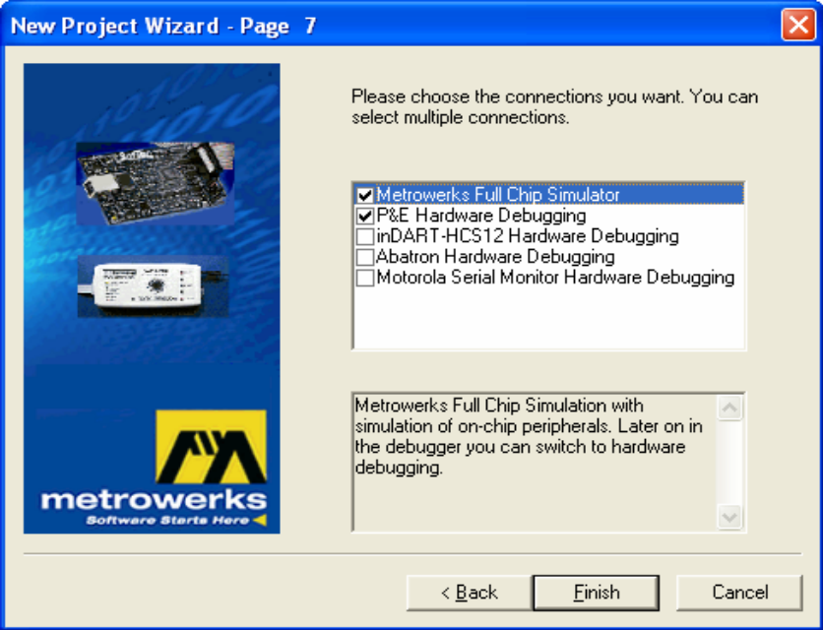
Figure 4.5 Connection settings window
6) Finally in bean inspector of ADC and SCI conversion time and baud rateare chosen.
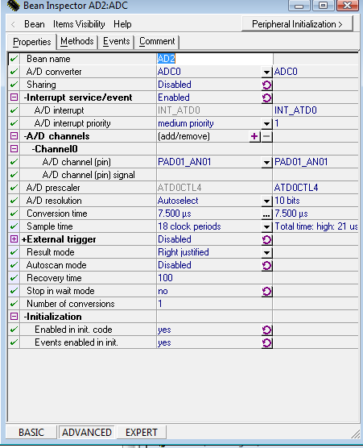
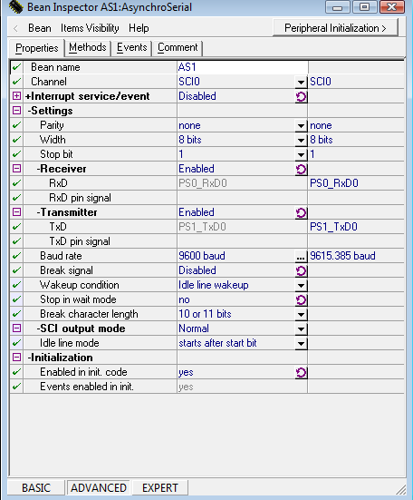
Figure 4.6 Bean selector window
4.2 ADC Flowchart and explanation
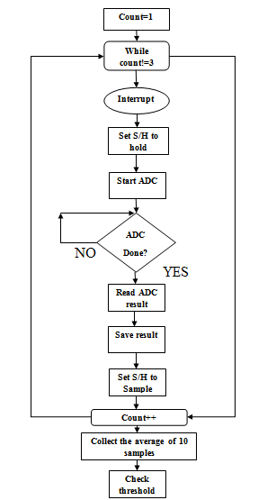
Figure 4.7 ADC flow chart
Generally 3 to 4 times readings are taken for accuracy. In this project three times the readings are taken from the ADC. Hence the count is set as three. When an external signal comes from any one of the sensor, the microcontroller sets interrupt flag. Since the sample and hold sub module disables its own clock and power when it’s not sampling. This interrupt flag brings the sample and hold circuit back to sample stage. After sampling is done the discredited value is sent to the A/D state machine to get the result in binary format. Result is saved in the A/D result register. Similarly procedure is followed for done for all three sample values. This value is compared with the threshold values set for each sensor output
4.3 Flowchart for GPS code
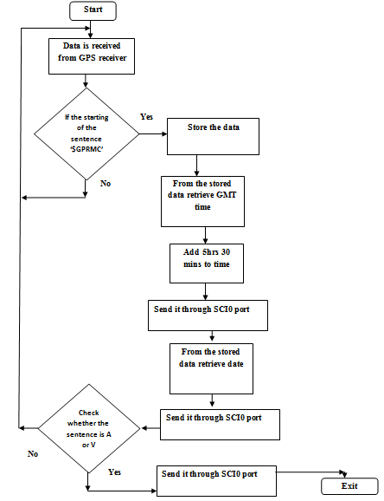
Figure 4.8 GPS flow chart

The MCU receives data from GPS (NMEA mode) and searches for "$GPRMC" and stores all the data following "$GPRMC" upto next '$' .Now from the stored data it retrieves the date, time and checks for validity and then it sends it through SCI to the GSM modem as shown in flowchart.

4.4 Flow Chart for GSM user code
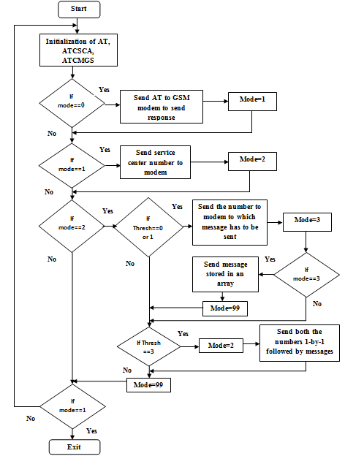
Figure 4.9 GSM flowchart
First AT variables are AT+, ATCSCA, ATCMGS are initialized in an array format. Then mode inspection is done. The MCU communicates with GSM modem as per the mode settings. If mode is set as 0, the AT commands are sent to the GSM modem. When mode is set 1 the service centre number of the service provider is sent to the GSM modem from MCU. If mode is set 2 the MCU transmits the mobile numbers to which the message has to be sent in case of emergency. For mode set as 3 the MCU will send the message to GSM modem. In this way these three modes are repeated in a cyclic fashion till the mode is 99. Finally messages will be sent to the concerned authorities from the GSM modem.

CHAPTER 5
TESTING

5.1 Introduction
Testing is an important aspect of every design cycle. Testing deals with the process of ensuring that every component is working in correctly and there is no fault anywhere. First the process of testing started as module wise testing, then the entire assembled system was tested (Full scale testing). It is done to check whether the desired output is got from the overall system by giving specified input. The 5 stages are.
- Stage-1 :MCU testing
- Stage-2: GSM Testing.
- Stage-3: GPS Testing.
- Stage-4: Sensor conditioning circuit testing.
- Stage-5: Software testing.

5.2 MCU testing
To test the microcontroller, it is connected to the PC. Then a program for alternative LED glow was downloaded to the debugger. It is a simple program in C language. The result was, out of the 8 LEDs 4 were glowing in alternative fashion. This confirmed the fact that the MCU is ready for the downloading the source code for EDS. A total of half a day was devoted for writing the code and testing the MCU.

5.3 GPS testing
Testing is done in two parts. First the receiver is given 5V through the voltage supply to ensure that it is working properly. Then the GPS module is interfaced with computer. The HyperTerminal which receives the GPS data is first configured setting the baud rate of 4800 baud. The receiver is compatible with RS232. Then the GPS antenna is kept inside a closed environment and data at the hyper terminal is received within few seconds. The following GPRMC sentence is considered for the project.
$$GPRMC,123519,A,4807.038,N,01131.000,E,022.4,084.4,230394,003.1,W*6A
GPRMC contains 12 de-limited words, where the 12th word is either A = active data or V = void data. If it is V = void data, then it is placed in an open environment and ensured that A = active data in received by the receiver.

5.4 Testing the Communication between the PC and GSM Modem
The LED interfaced on the GSM used for indicating the signal strength. A glowing LED indicates that there is sufficient signal to carry on the transmission process. Next the GSM modem is connected to the PC and HyperTerminal program is started. To ensure that there is a proper communication between the PC and GSM/GPRS modem, “AT” command is entered in the terminal program to perform the test. When the GSM/GPRS modem or mobile phone receives “AT”, it sends back the final code “OK” to indicate that it has received the command successfully.

5.5 Sensor conditioning circuitry testing
Testing was done in two parts. In the first stage, the entire board is visually inspected for any deviations from the circuit diagram, when a few were found they were rectified. In the second stage, the board was tested for continuity using a multimeter, which is done to ensure correct electrical contact between various components. Then each sensor module testing is done individually, by giving the specified inputs. For the pressure sensor a voltage divider is used to get lower range of input voltages.

5.6 SOFTWARE TESTING
The code written for the Emergency Detection System is tested all throughout the process because it’s prone to many errors. The code is written in C language in Code Warrior IDE tool. It is checked for various possibilities of occurrences of errors. This phase took the most of the time in the whole testing process. Errors like syntax errors, run time errors were debugged successfully.

CHAPTER 6
FUTURE ENHANCEMENTS
The project was designed to serve more as fully fledged practical solution rather than just “proof to concepts”. It aims to find an accurate solution for military purposes taking care of the data reliability. Further enhancements that can be done are.
- Use of MCU’s with Nano Watt technology for power saving purposes. For example the PIC16F88.
- Implementing the solar energy harvesting technology .This will be really useful when the military vehicles are in the desserts during the summer. An energy harvesting circuit can be implemented, which will harvest solar energy and convert into electrical energy. Thus the need for external power supply can be completely omitted.
- Improvement of communication. One can use a 3G communication interface (GPRS, EGPRS, UMTS) for extended range of data and higher speed and better bandwidth.
- The number of sensors can be increased upto 8. Because the ADC is an 8 bit channel.
With all the above features the EDS can be optimized as a whole.

REFERENCE LIST
[1] Jonathan W. Valvano, “Embedded Microcomputer Systems, Real time”, Thomson Learning, Inc., Second Indian Reprint, 2007.
[2] http://www.robotica.co.il/hardware/DataSheets/motorola/MC9S12DP256.pdf
[3] Theodore S. Rappaport, “Wireless Communications Principle and Practice”, Prentice –Hall India, Second Edition, 2007.
[4] http://www.national.com/ds/LM/LM35.pdf
[5] http://focus.ti.com/lit/ds/symlink/ua741.pdf
[6] Adel S. Sedra, Kenneth C .Smith, “Microelectronic Circuits”, Oxford University Press, Fifth Edition, 2004.
[7] http://www.hwsensor.com/English/PDF/sensor/MQ-2.pdf
[8] Ernest O. Doebelin, “Measurement Systems, Application and Design”, Tata McGraw-Hill, Fifth Edition, 2005.

